Determinants of Job Placements

Sree Krishnakanth Gurram
ISM 6137 Statistical Data Mining

Executive Summary
In the landscape of Hiring agencies, understanding the interplay between candidate attributes and the individual differences that set them apart is paramount. This project delves to answer a couple of research questions.

Problem
The project aimed to understand the factors influencing candidates' job offers and progression through the recruitment process, particularly their likelihood of receiving job offers at various stages. The study focused on a dataset containing 100,000 candidate records, tracking their progress through various recruitment stages.

Data
The dataset consisted of candidate-specific information, including citizenship status, years of work experience, desired salary, primary skills, and time-stamped stage progression, listed job features, recruiter specific features etc.

Analysis
We conducted a comprehensive analysis of the data, employing various statistical models. For the influence of candidate features on job offer analysis, I GLM mixed model with a binomial distribution and included random effects to account for individual variability. For stage wise progression, I employed survival analysis to estimate the hazard of progressing to the next stage.

Key Findings
1. Impact on Job offer: Our analysis revealed that the likelihood of progressing to the next stage was influenced by multiple factors. US citizenship is positively associated with successful job offers, while years of work experience, primary skills and desired salary exhibited negative effects.

2. Interaction Effects: The interaction between the average primary skill experience and desired salary was found to positively affect the job offer emphasizing the importance of skill proficiency relative to salary expectations.

3.Random Effects: Random effects, capturing individual candidate variability, were significant in our models, underlining that not all candidates follow the same progression pattern.

In summary, analysis provided insights into the dynamics of candidate progression throughout the recruitment process. Understanding the influence of candidate attributes and their interactions can inform recruitment strategies and improve the efficiency of the hiring process.

Problem Definition and Significance
The business problem at hand revolves around the need to optimize the recruitment process by understanding the factors influencing a candidate’s chances of receiving a job offer and dynamics of progression through the various recruitment stages. So that the Hiring and staffing agencies better understand the market and successfully place its candidates.

How this is significant?

Efficient Talent Acquisition: Attracting and retaining top talent is crucial for business success, understanding how different candidate attributes affect their prospects of securing job offers is paramount. Optimizing this process can lead to more efficient and effective talent acquisition.
Competitive Advantage: In today's competitive job market, organizations are continually vying for the best candidates. The ability to tailor recruitment strategies based on data-driven insights can provide a significant competitive advantage.
Unique Insights from Agencies: Data-driven insights can streamline & optimize entire screening, evaluating and matching candidates’ process. So that the agencies can better navigate through latest employment trends and serve diverse industries, offering a broad perspective on placements.
Resource Allocation: Understanding the candidate attributes that matter the most can help the hiring agencies allocate their resources more effectively. It ensures that time and effort are directed towards the aspects that have the greatest impact on securing job offers.

The latest employment statistics highlight the Intensifying competition in the talent acquisition sphere. A report from Deloitte Insights states that pandemic created a stark new reality for employees working in higher educational institutions, where they want to switch to high paying jobs and wishing for a healthy work life balance.

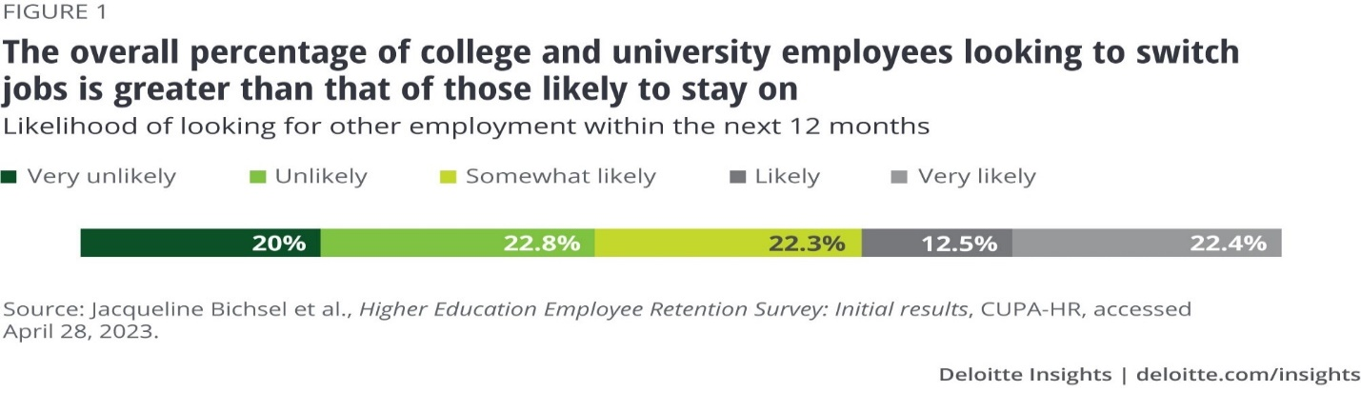
Popular Job postings platform Indeed’s research division Hiring Lab in its latest US labor market updated highlights that Recruiting Intensity is Fading out but remains High.

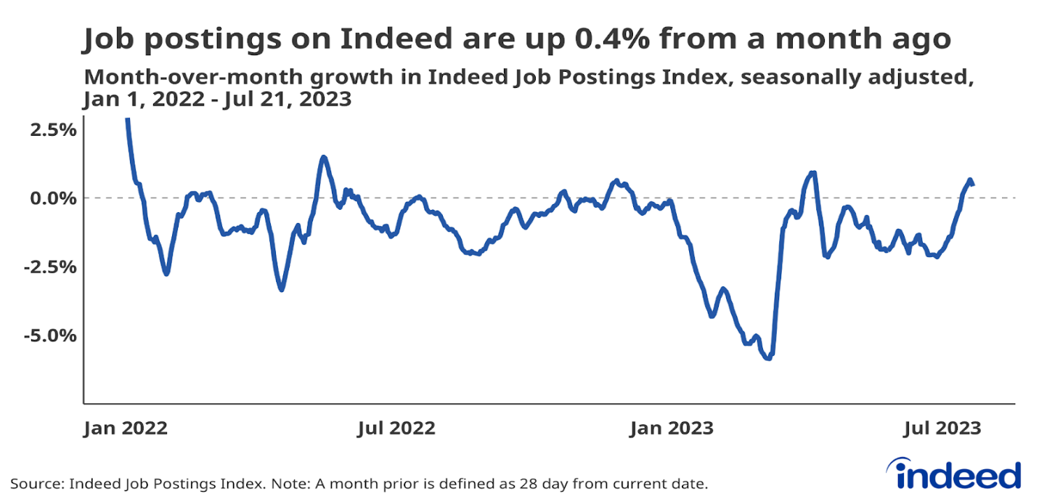

The above graph shows total postings ticked up but have declined month-over-month for most part of the 2023. The same report states that the trend of great resignations is continuing and quitting remains above its pre-pandemic level.
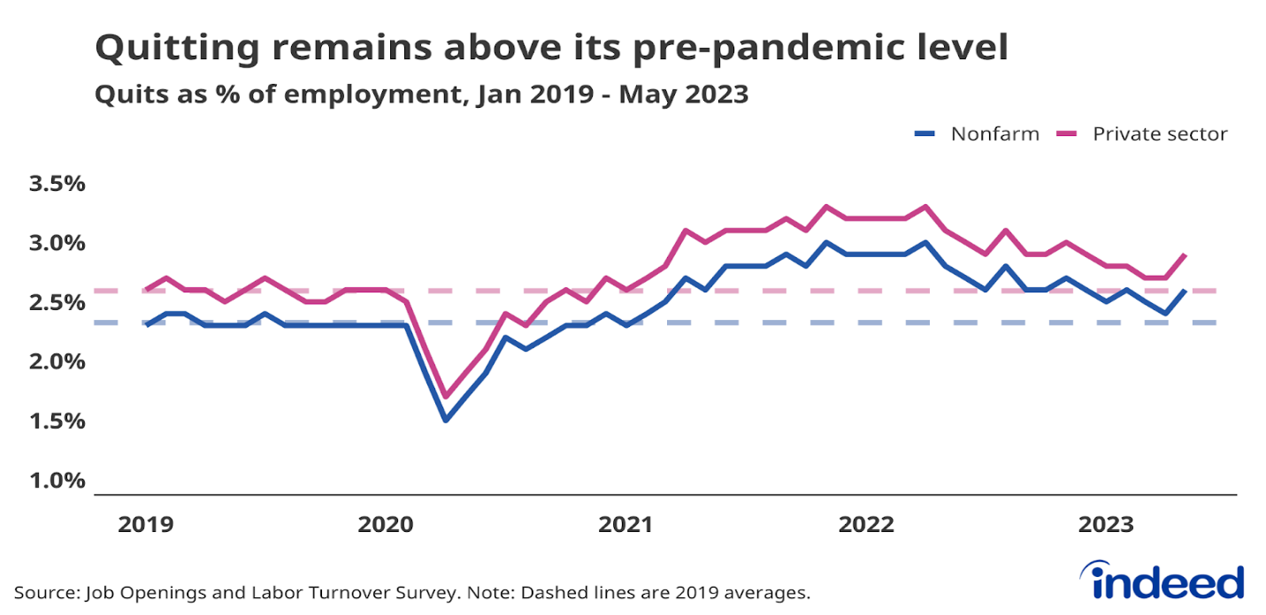
The statistics mentioned earlier are just a glimpse of a much bigger issue. Many people are entering the job market, and it's crucial in today's context to comprehend how job placements work. This understanding can help hiring agencies do a better and faster job of placing their candidates. While the dataset offers many avenues for exploration, in this project my main goal is to address the following questions:
- How do different candidate attributes influence their chances of getting a job offer? while considering individual differences between candidates?
- What is the likelihood of a candidate progressing to the next stage, given certain predictor variables?
Prior Literature
- In a study conducted to understand how college prestige, major and gender impact job search prospects, and Initial wages of new graduates in the Beijing area. They found.
- Graduates from prestigious universities find jobs faster and wages higher.
- Engineering and Business Majors find jobs more swiftly than those in Law and sciences. However, graduates from liberal arts and social sciences tend to earn higher wages.
- Female graduates tend to find jobs quicker than males but earn less.
Data and Methodology
- Data comes from a survey conducted by an educational consulting company. This company collects information about the unemployment status of new graduates.
- Population size – 10,639, Sample size for the study – 8212 from 82 reputed universities, universities, and colleges.
- They used parametric survival approach (Weibull regression) to analyze the factors affecting duration of employment.
- For wage estimation, OLS regression techniques are employed.
In summary, prestige, major and sex exert different degrees of influence on initial wages. Graduating from a low reputed college and pursuing certain majors like agriculture or medicine have a greater negative impact on initial wages compared to other factors.
Data Source/ Preparation
The dataset for this project is sourced from a leading hiring agency and this is a live dataset.
Structure of dataset
- 90+ variables capturing candidate specific features, various stages of interviewing process and corresponding time stamps, Listed job features, Recruiter specific features etc.
- Dataset has a total of 100,000 rows; Single candidate has records applied for multiple Jobs, and each stage of recruitment has a record.
- Candidate specific features like personal details, educational details, skills are included.
- Listed job features like Job title, salary range, number of openings, Industry sector is included.
- Stages of recruitment process: 5 stages from assigning a Job order to successful offer
- Dependent variable: Job offer (offer_placement)
Given the proprietary nature of the dataset, comprehensive details regarding the data collection process remain undisclosed.
Notable facts of the dataset
- Total unique number of candidates: 19734.
- Total unique number of Job Orders: 27146.
- Average number of jobs each candidate applied for: 2.2.
- Maximum number of jobs a candidate applied for: 38.
- Minimum number of jobs a candidate applied for:1.

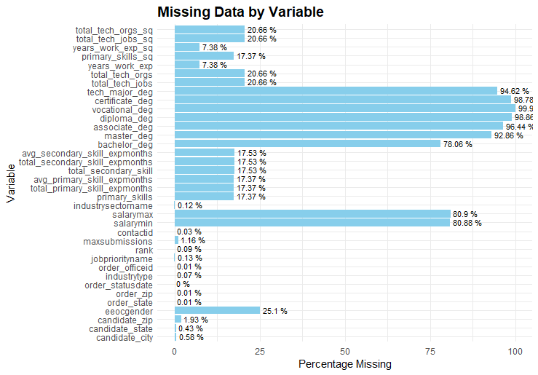

The above chart shows, percentage of missing data for the variables having missing values and variables like annual salary, desired salary is defaulted to 0 for some unknown reason or 0’s might be placeholder data while filling an application. Having too much missing data made the data cleaning process a bit challenging.
Handling Missing values
Missing values are only handled for the variables that are included in the analysis. All the variables included and the rationale behind their inclusion will be discussed in subsequent sections. Different strategies are incorporated to handle the missing values to ensure near original distribution of data.
- US Citizenship (1 & 0) variable is randomly imputed based on original observed ratio.
- Gender is randomly imputed in the ratio of 1:1 between male and female.
- Annual salary and Desired salary are imputed by global median. Defaulted values to 0’s is replaced by calculating grouped median of respective annual and desired salaries of Industry type and experience of candidate.
- Industry type is imputed by mode of the variable.
- All the skills related variables are imputed by corresponding global medians.
- Despite the influence of educational related variables on job offer. I have not included it in the analysis due to the high percentage of missing data.
All the incorrect variable types are converted to suitable types.
Variable choice
While the dataset is comprehensive and demands multiple aspects to study. For this project, only certain variables that are identified as significant are included and the rest of the other variables are dropped.

Variable | Rationale/ Description
Order id | Uniquely identifies each job listing
Category name | Identifies the stage of recruitment process, required to analysis of stage wise progression
Us citizen | Citizenship status does influence offer. Since the data is based in US
eeocender | To identify the influence on gender on offer
Annual salary | Candidates tend to apply for the offer only If the listed annual salary is appealing.
Desired salary | One to the metric to screen the job applications
Industry type | Identifies the listed job by specific industry
Ordertypename | Identifies the nature of job like Temporary, contractual, Full time etc.
industrysectorname | Identifies the job by sector. If job is in commercial, state govt or Fed govt.
candidateid | Requirement for analysis of variability among candidates
Primary_skills | Highly skilled candidates are sought after and certainly have a certain degree of influence on the offer.
total_primary_skill_expmonths
total_secondary_skill
total_secondary_skill_expmonths
avg_primary_skill_expmonths
avg_secondary_skill_expmonths
years_work_exp | Candidate with prior experience have an edge over a candidate with no experience.
offer_placement | Target variable for the analysis
dob | Used to calculate the age of the candidate. Age has certain degree of influence on type of job candidate is applying for
eeocethinicoriginname | To identify the influence on ethnicity on offer

Feature Engineering
- Age: calculated age of the candidate from date of birth.
- numeric_stage: Assigned a numeric value to different stages of recruitment process as per order of progression.
- Next_stage: Identifies the next stage of each candidate in the recruitment process.
- Progressed: Binary variable that identifies if the candidate progressed to the next stage of recruitment process.
Descriptive Analysis and Data Visualizations

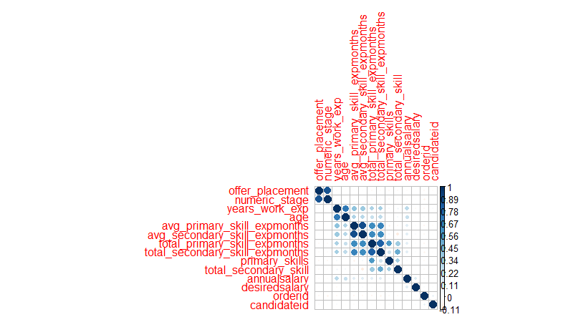

From above, some expected variables (age&total_experience), (offer_placement & numeric_stage) show high correlation. Due to limitation on knowledge of data collection process. High correlation between primary and secondary skill variables is hard to explain.

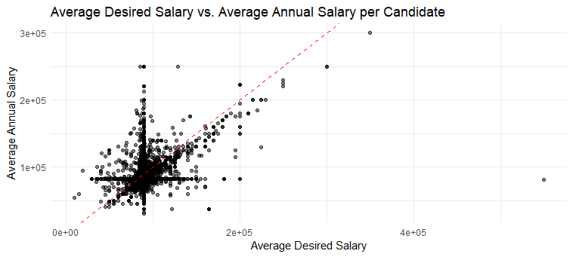
From the above plot, it can be observed that candidate’s salary expectations are higher than the employers willing to offer.

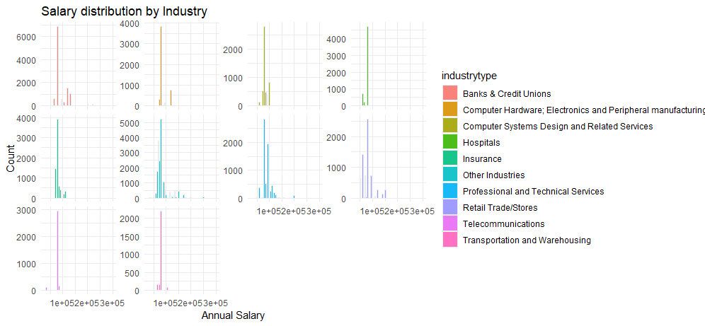

The above, salary distribution of top 10 industries. All the industries show Unimodal and Bimodal distributions as expected. The peaks represent the most frequented salary range.

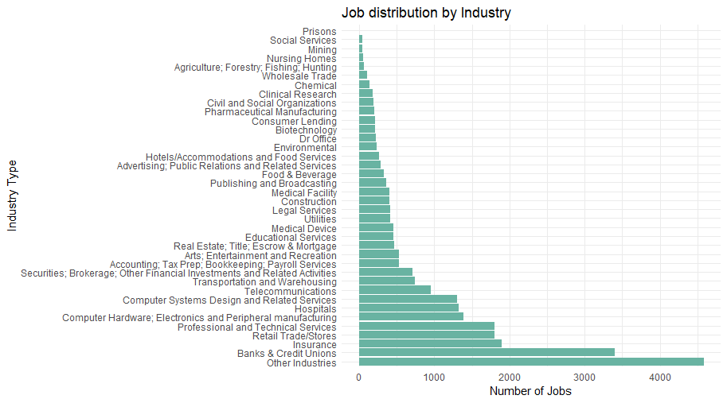
The above shows listed job distribution by Industry in decreasing order. With banks, Insurance, Manufacturing and Technology industries being leading employers.

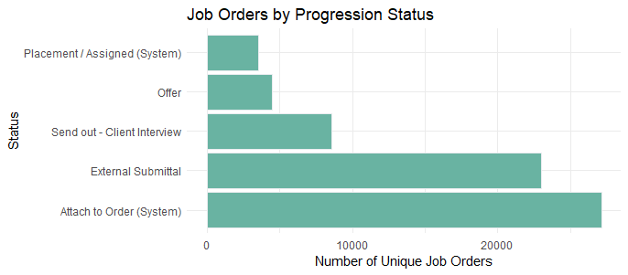

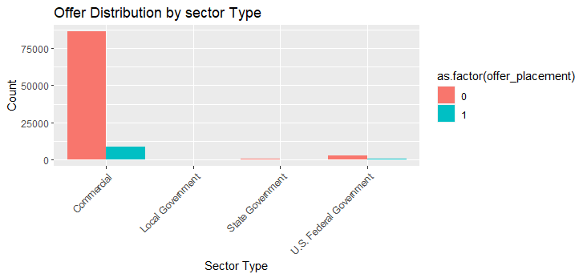

From the above plots, most of candidates are being screened out between 2 & 3 stage and need for hiring agencies to identify the reasons to improve the conversion rate and as expected commercial sector being the leading job provider.
Models
- How do different candidate attributes influence their chances of getting a job offer? while considering individual differences between candidates?

Given the Hierarchical structure of data. I chose a multilevel modelling approach for the analysis and the target variable being binary. I used a multi-level logistic regression model.
I ran multiple models by changing the combination of variables and found the following models showing better results.
model _equation = offer_placement ~ us citizen + avg_primary_skill_expmonths + years_work_exp + desiredsalary + primary_skills + (1 | candidateid)
control_params = glmerControl (optimizer = "bobyqa”, optCtrl = list (maxfun = 10000))

logistic_model = glmer (model_equation, data=working_set, family=binomial(link="logit"), control = control_params)
For the second model, introduced an interaction term between avg_primary_skill_expmonths & desiredsalary. Assuming a candidates’ experience, effect on the offer may vary based on desired salary i.e., candidates with highly specialized skills may have higher salary expectations and might be more selective about the job offers.
model_equation_interaction = offer_placement ~ uscitizen + avg_primary_skill_expmonths + years_work_exp + desiredsalary + primary_skills + avg_primary_skill_expmonths: desiredsalary + (1 | candidateid)

logistic_model_interactions = glmer (model_equation_interaction, data=working_set, family=binomial(link="logit"), control = control_params)

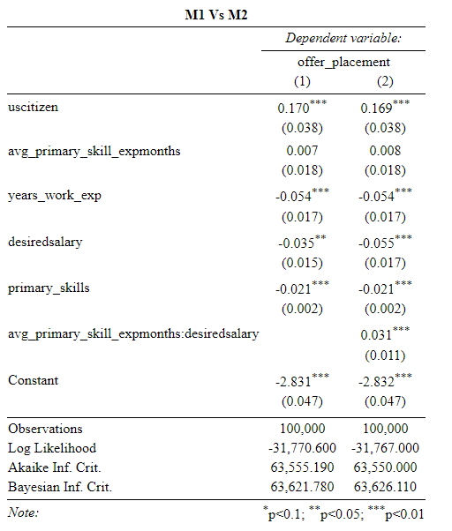
From the above results, Even though adding an interaction term made the model complex, but interaction is significant. Comparing AIC for goodness of fit, Interaction model has lower AIC and better among the two.

- What is the likelihood of a candidate progressing to the next stage, given certain predictor variables?

For this analysis, I created two new variables, a. next_stage which identifies the next stage that candidate has to appear and progressed, which identifies if the candidate has progressed to next_stage.

I used survival analysis approach by treating progressed as a time entity as every candidate must pass through one stage at a time.
cox_model = coxph (Surv (numeric_stage, progressed) ~ uscitizen + years_work_exp + desiredsalary + primary_skills, data = working_set_copy)
coef exp(coef) se(coef) z Pr(>|z|)
uscitizen 0.0839312 1.0875541 0.0160045 5.244 1.57e-07 ***
years_work_exp 0.0299088 1.0303606 0.0053620 5.578 2.43e-08 ***
desiredsalary -0.0008705 0.9991299 0.0054212 -0.161 0.872
primary_skills -0.0044765 0.9955335 0.0006736 -6.646 3.02e-11 ***
---
Signif. codes: 0 ‘***’ 0.001 ‘**’ 0.01 ‘*’ 0.05 ‘.’ 0.1 ‘

Results
- There is a significant effect of predictor variables on the offer placement. Significant predictors include U.S citizenship (positive effect), primary skills (negative effect), years of work experience (negative effect) and desired salary (negative effect) and model accounts for individual variability using a random effect for candidateid.
- This shows that employers might consider the desirability of US citizenship in offering a job or importance of aligning job candidates’ salary expectations with company’s budget.
- The Cox proportional hazards model summary indicates that being a U.S. citizen and having more years of work experience are associated with an increased risk of progression, while desired salary has minimal impact. Additionally, having specific primary skills is associated with a slightly lower risk of progression.

Recommendations
- Candidate Selection
- Consider giving preference to candidates who have prior experience and unique primary skills required for the job, as this is associated with a higher likelihood of job placement. Ensure that job postings and candidate matching prioritize candidates having these. So that these candidates can be forwarded, and additional time can be spent on candidates who are fresh out college.
- Desired salary considerations
- desired salary has a limited impact on job placement. Still, it's crucial to align candidates' salary expectations with client budgets. Educate candidates about market salaries and negotiate when necessary to ensure a fair and competitive compensation package.
- Citizenship awareness
- While the models US citizenship has more desirability among the employers, it might entice the hiring agency to prioritize them over non-citizen candidates which might land them into legal troubles. So, It is essential to comply with all legal requirements and proactive measures should be taken to support non US citizen candidates as well.
References
Kong, J. (2015). Determinants of graduates’ job opportunities and initial wages in China. InternationalLabourReview,156(1), 99-112. https://onlinelibrary.wiley.com/doi/10.1111/j.1564-913X.2015.00030.x

Clark, C., Cluver, M., & Selingo, J. J. (2023, May 17). Trend No. 4: Talent management becomes a strategy. Deloitte Insights. https://www2.deloitte.com/us/en/insights/industry/public-sector/articles-on-higher-education/talent-management-in-higher-education.html

Stahle, C., & Bunker, N. (2023, July 27). July 2023 US Labor Market Update: Recruiting Intensity Is Fading but Remains High. Hiring Lab. https://www.hiringlab.org/2023/07/27/july-2023-us-labor-market-update/

Appendix
rm(list = ls())
install.packages(c("readr" ,"tidyverse"))
install.packages("car")
library(car)
library(readr)
library(tidyverse)
library(dplyr)
library(ggplot2)
library(tidyr)
library(caret)
library(lme4)
setwd("D:/Fall'23/SDM")
masterset = read.csv("candidates_sample.csv")
working_set = masterset[, c(3,5,16,17,18,21,22,28,29,38,39,40,41,50,51,61,
63,69,70,71,72,73,74,75,76,77,78,79,80,86,87)]
working_set = working_set[, -c(8,9)]
working_set$annualsalary = as.numeric(working_set$annualsalary)
working_set$hourlyrate = as.numeric(working_set$hourlyrate)
working_set$desiredsalary = as.numeric(working_set$desiredsalary)
working_set$desiredhourly = as.numeric(working_set$desiredhourly)
working_set$uscitizen = as.integer(working_set$uscitizen)
#converting dob column to date type and creating variable age
invalid_dates = working_set$dob[is.na(as.Date(working_set$dob, format="%b %d %Y %I:%M%p"))]
print(invalid_dates)
working_set$dob[working_set$dob == "-"] = NA
working_set = working_set %>% mutate(dob = as.Date(dob, format="%b %d %Y %I:%M%p"))
working_set = working_set %>%
mutate(age = ifelse(!is.na(dob), as.integer(difftime(Sys.Date(), dob, units = "weeks") / 52.25), NA))
str(working_set)
# Unique number of candidates
unique_candidates = length(unique(working_set$candidateid))
# Unique number of order IDs
unique_orderids = length(unique(working_set$orderid))
cat("Unique number of candidates:", unique_candidates, "\n")
cat("Unique number of order IDs:", unique_orderids, "\n")
# Finding max, min and mean job applied by candidates.
job_counts_per_candidate = working_set %>%
group_by(candidateid) %>%
summarise(num_jobs = n_distinct(orderid))
average_jobs = mean(job_counts_per_candidate$num_jobs)
max_jobs_applied = max(job_counts_per_candidate$num_jobs)
min_jobs_applied = min(job_counts_per_candidate$num_jobs)
# Printing results
cat("On average, each candidate applies for:", average_jobs, "jobs.\n")
cat("Maximum number of jobs a candidate applied for:", max_jobs_applied, "\n")
cat("Minimum number of jobs a candidate applied for:", min_jobs_applied, "\n")
# Handling missing values
working_set$industrysectorname[is.na(working_set$industrysectorname)] = "Commercial" #mode imputation
sum(is.na(working_set$industrysectorname))
# Gender missing values - replacing NULL's with NA and distributing total NA's in 1:1 btw male and female randomly
working_set$eeocgender[working_set$eeocgender == "NULL"] = NA
set.seed(123)
num_na = sum(is.na(working_set$eeocgender))
print(num_na)
# vector of "Male" and "Female" of length num_na
replacement_values = sample(c(rep("Male", num_na %/% 2), rep("Female", num_na - num_na %/% 2)), num_na)
working_set$eeocgender[is.na(working_set$eeocgender)] = replacement_values
sum(is.na(working_set$eeocgender))
# Imputing NA's in industry type with mode
industry_frequency=table(working_set$industrytype)
mode_industrytype = names(industry_frequency)[which.max(industry_frequency)]
print(mode_industrytype)
working_set$industrytype[is.na(working_set$industrytype)] = mode_industrytype
sum(is.na(working_set$industrytype))
# observation : For couple of candidate ID's salaries are off by a factor 1000
working_set$annualsalary[working_set$candidateid == 17575282 & working_set$annualsalary == 57.69] = 57690
working_set$annualsalary[working_set$candidateid == 17012798 & working_set$annualsalary == 105] = 105000
table(working_set$annualsalary)
summary(working_set$years_work_exp)
# Imputing work experience with median
median_experience = median(working_set$years_work_exp, na.rm = TRUE)
working_set$years_work_exp[is.na(working_set$years_work_exp)] = median_experience
summary(working_set$years_work_exp) # distribution is similar
# Replacing annual salaries of 0's with median salary range of grouping industry type and work experience.
median_salaries = working_set %>%
filter(annualsalary > 0) %>%
group_by(industrytype, years_work_exp) %>%
summarise(median_annualsalary = median(annualsalary, na.rm = TRUE))
# merging median_salaries to our working_set
working_set = left_join(working_set, median_salaries, by = c("industrytype", "years_work_exp"))

sum(is.na(working_set$median_annualsalary)) # too many missing values,
# reason: there are many null values values for combination of industry type and experience.
# To reduce this missing values , I am imputing missing values in median salaries by global median of annual salaries.

# replacing missing values in median_annual salary by median of annualsalary (global median)
global_median = median(working_set$annualsalary[working_set$annualsalary > 0], na.rm = TRUE)
working_set$median_annualsalary[is.na(working_set$median_annualsalary)] = global_median
sum(is.na(working_set$median_annualsalary)) # 0 missing values
Pre_dist_annual_salary = summary(working_set$annualsalary) # Before Imputation
print(Pre_dist_annual_salary)
# Imputing Null values in annual salary by global median.
working_set$annualsalary[is.na(working_set$annualsalary)] = global_median
# Replace the 0's in the annualsalary column using the median_annualsalary column
working_set$annualsalary[working_set$annualsalary == 0] = working_set$median_annualsalary[working_set$annualsalary == 0]
post_dist_annual_salary = summary(working_set$annualsalary) # Post Imputation
print(post_dist_annual_salary)
# For desired salary - same approach as annual salary
pre_dist_desired_salary = summary(working_set$desiredsalary)
print(pre_dist_desired_salary)
# observation: some desiredsalries of candidates are off by factor of 1000
off_values = c(15, 19, 35, 50, 52, 60, 65, 70, 114)
# indices where desiredsalary is one of the off_values
indices = which(working_set$desiredsalary %in% off_values)
count = sum(working_set$desiredsalary %in% off_values)
print(count)
# Multiply these values by 1000
working_set$desiredsalary[indices] = working_set$desiredsalary[indices] * 1000

print(working_set$desiredsalary[indices])

table(working_set$desiredsalary)
# Imputing Null values in desired salary by global median
global_median_desired = median(working_set$desiredsalary[working_set$desiredsalary > 0], na.rm = TRUE)
working_set$desiredsalary[is.na(working_set$desiredsalary)] = global_median_desired
sum(is.na(working_set$desiredsalary)) # 0 missing values
# replacing 0's in desired salary by median of desired salary grouped by experience of the candidate and industrytype and experience
median_desiredsalary = working_set %>%
filter(desiredsalary > 0) %>%
group_by(industrytype, years_work_exp) %>%
summarise(median_desiredsalary = median(desiredsalary, na.rm = TRUE))
# merging to working_set
working_set = left_join(working_set, median_desiredsalary, by = c("industrytype", "years_work_exp"))
sum(is.na(working_set$median_desiredsalary))
working_set$median_desiredsalary[is.na(working_set$median_desiredsalary)] = global_median
working_set$desiredsalary[working_set$desiredsalary == 0] = working_set$median_desiredsalary[working_set$desiredsalary == 0]
summary(working_set$desiredsalary)
colSums(is.na(working_set))
# Imputing skills related col missing values with median
working_set$primary_skills[is.na(working_set$primary_skills)] = median(working_set$primary_skills, na.rm = TRUE)
working_set$total_secondary_skill[is.na(working_set$total_secondary_skill)] = median(working_set$total_secondary_skill, na.rm = TRUE)
working_set$total_primary_skill_expmonths[is.na(working_set$total_primary_skill_expmonths)] = median(working_set$total_primary_skill_expmonths, na.rm = TRUE)
working_set$total_secondary_skill_expmonths[is.na(working_set$total_secondary_skill_expmonths)] = median(working_set$total_secondary_skill_expmonths, na.rm = TRUE)
working_set$avg_primary_skill_expmonths[is.na(working_set$avg_primary_skill_expmonths)] = median(working_set$avg_primary_skill_expmonths, na.rm = TRUE)
working_set$avg_secondary_skill_expmonths[is.na(working_set$avg_secondary_skill_expmonths)] = median(working_set$avg_secondary_skill_expmonths, na.rm = TRUE)
# Imputing uscitizen randomly in observed ratio in the data set to maintain the distribution . as there are around 53000 Nulls
unique(working_set$uscitizen)
# Before replacement
table(working_set$uscitizen)
observed_ratio_1 <- sum(working_set$uscitizen == 1, na.rm = TRUE) /
(sum(working_set$uscitizen == 1, na.rm = TRUE) + sum(working_set$uscitizen == 0, na.rm = TRUE))
missing_na <- sum(is.na(working_set$uscitizen))
print(missing_na)

set.seed(123)
replacement <- sample(c(rep(1, round(missing_na * observed_ratio_1)),
rep(0, missing_na - round(missing_na * observed_ratio_1))))
working_set$uscitizen[is.na(working_set$uscitizen)] <- replacement
# After replacement
table(working_set$uscitizen)
class(working_set$uscitizen)
colSums(is.na(working_set))
working_set = working_set[, -c(3,5,7,9,11,24,25,26,27,31,32)]

colnames(working_set)
# aggregating data at candidate level to get max recruitment stage candidate reached.

stage_map = c("Attach to Order (System)" = 1, "External Submittal" = 2, "Send out - Client Interview" = 3,
"Offer" = 4, "Placement / Assigned (System)" = 5)

working_set$numeric_stage = as.numeric(stage_map[working_set$categoryname])
# aggregate data
aggregated_data = working_set %>%
group_by(candidateid, orderid) %>%
summarise(
max_stage_reached = ifelse(all(is.na(numeric_stage)), NA, max(numeric_stage, na.rm = TRUE)),
total_unique_stages_passed = n_distinct(numeric_stage),
offer = first(offer_placement)

)
write.csv(aggregated_data ,"newaggregateddata.csv")

print(colnames(working_set))

# annual salary distributions across top 10 industry types

top_10_industries = names(sort(industry_frequency, decreasing = TRUE)[1:10])
subset_top10_industries = working_set[working_set$industrytype %in% top_10_industries, ]

ggplot(subset_top10_industries, aes(x = annualsalary, fill = industrytype)) +
geom_histogram(binwidth = 5000, color="#e9ecef", alpha=0.9, position = "identity") +
facet_wrap(~ industrytype, scales = "free_y") +
labs(title = "Salary distribution by Industry",
x = "Annual Salary",
y = "Count") +
theme_minimal() +
theme(strip.background = element_rect(fill="white", colour="white", linewidth =1),
strip.text.x = element_blank())
# avg desired salary Vs avg annual salary
aggregated_salary <- working_set %>%
group_by(candidateid) %>%
summarise(
avg_desired_salary = mean(desiredsalary),
avg_annual_salary = mean(annualsalary)
)

ggplot(aggregated_salary, aes(x = avg_desired_salary, y = avg_annual_salary)) +
geom_point(alpha = 0.5) +
geom_abline(intercept = 0, slope = 1, color = "red", linetype = "dashed") +
labs(
title = "Average Desired Salary vs. Average Annual Salary per Candidate",
x = "Average Desired Salary",
y = "Average Annual Salary"
) +
theme_minimal()
#work experience distribution by gender
ggplot(working_set, aes(x = eeocgender, y = years_work_exp)) +
geom_boxplot(outlier.color="red", outlier.shape=16, outlier.size=2) +
labs(
title = "Distribution of Years of Work Experience by Gender",
x = " Gender",
y = "Years of Work Experience"
) +
theme_minimal()
# Compute the correlation matrix
cor_matrix = cor(working_set[, sapply(working_set, is.numeric)], use="complete.obs")

names(cor_matrix) = abbreviate(names(cor_matrix) , minlength = 8)
# considering only numeric columns

# Visualize the correlation matrix
library(corrplot)
corrplot(cor_matrix, method = "circle" , order = "hclust" ,t1.cex = 0.5 ,is.corr = FALSE)
write.csv(working_set ,"Finalproject_dataset.csv")
# Distribution of Jobs by Industry Type
# Aggregate data
industry_jobs = working_set %>%
group_by(industrytype) %>%
summarise(unique_jobs = n_distinct(orderid))
# Plot
ggplot(industry_jobs, aes(x = reorder(industrytype, -unique_jobs), y = unique_jobs)) +
geom_bar(stat = "identity", fill = "#69b3a2") +
coord_flip() +
labs(title = "Job distribution by Industry",
x = "Industry Type",
y = "Number of Jobs") +
theme_minimal()
# Job progression for Unique orderID
# Set the order for the categoryname factor
working_set$categoryname <- as.character(working_set$categoryname)
working_set$categoryname <- as.factor(working_set$categoryname)
levels(working_set$categoryname)
table(working_set$categoryname)
levels_order = c("Attach to Order (System)", "External Submittal", "Send out - Client Interview", "Offer", "Placement / Assigned (System)")
working_set$categoryname = factor(working_set$categoryname, levels = levels_order)
working_set$categoryname <- as.character(working_set$categoryname)
working_set$categoryname <- as.factor(working_set$categoryname)
working_set$categoryname[is.na(working_set$categoryname)] <- "Send out - Client Interview"
# Check the table again to confirm
table(working_set$categoryname)
levels(working_set$categoryname)
# Aggregate data by categoryname and count unique orderids
unique_orders = working_set %>%
group_by(categoryname) %>%
summarise(unique_orders_count = n_distinct(orderid))
# Create the bar plot
ggplot(unique_orders, aes(x = categoryname, y = unique_orders_count)) +
geom_bar(stat = "identity", fill = "#69b3a2", color = "#e9ecef") +
coord_flip() +
labs(
title = "Job Orders by Progression Status",
x = "Status",
y = "Number of Unique Job Orders"
) +
theme_minimal()
# offer distrubution by sector type
ggplot(working_set, aes(x = industrysectorname, fill = as.factor(offer_placement), group=offer_placement)) +
geom_bar(position = "dodge") +
theme(axis.text.x = element_text(angle = 45, hjust = 1)) +
labs(title = "Offer Distribution by sector Type",
x = "Sector Type",
y = "Count")
write.csv(working_set ,"Finalproject_dataset.csv")
# Replacing spaces with underscores
colnames(working_set) <- gsub(" ", "_", colnames(working_set))
working_set$eeocgender <- as.factor(working_set$eeocgender)
model_equation = offer_placement ~ uscitizen +
avg_primary_skill_expmonths +
years_work_exp +
desiredsalary +
primary_skills +
(1 | candidateid)
control_params = glmerControl(optimizer = "bobyqa" , optCtrl = list(maxfun = 10000))
working_set$avg_primary_skill_expmonths <- scale(working_set$avg_primary_skill_expmonths)
working_set$years_work_exp <- scale(working_set$years_work_exp)
working_set$desiredsalary <- scale(working_set$desiredsalary)
logistic_model = glmer(model_equation , data=working_set, family=binomial(link="logit"), control = control_params)
summary(logistic_model)
stargazer::stargazer(logistic_model , title = "Logistic_Model" , align = TRUE, out = "logistic_Model.tex")
random_effects = ranef(logistic_model)$candidateid
head(random_effects)
# Get predicted probabilities
working_set$probabilities = predict(logistic_model, type = "response")
working_set$logit = log(working_set$probabilities / (1 - working_set$probabilities))
predictor_vars = c("avg_primary_skill_expmonths", "years_work_exp", "desiredsalary", "primary_skills")
# Using lapply to loop through each predictor variable
quartile_means_list = lapply(predictor_vars, function(var) {
# Create quartile variable name
quartile_var_name = paste0("quartile_", var)
# Mutate to create the quartile variable
data = working_set %>%
mutate(!!quartile_var_name := ntile(!!sym(var), 4))
# Compute the mean of the logit values for each quartile
quartile_means = data %>%
group_by(!!sym(quartile_var_name)) %>%
summarize(mean_logit = mean(logit))
return(quartile_means)
})
# Naming the list elements by predictor variable
names(quartile_means_list) = predictor_vars
install.packages("gridExtra")
library(gridExtra)
# Generate the list of ggplot objects
plot_list <- lapply(1:length(quartile_means_list), function(i) {
# Extract the current dataframe
current_data <- quartile_means_list[[i]]

# Plot title
plot_title <- paste0("Logit vs. Quartile of ", predictor_vars[i])

# Return the ggplot object
ggplot(current_data, aes_string(x = names(current_data)[1], y = "mean_logit")) +
geom_point(aes(colour = mean_logit)) +
geom_line(aes(group = 1)) +
ggtitle(plot_title) +
theme_minimal() +
labs(x = "quartile", y = "Mean Logit Value")
})
# Arrange and display the plots in a grid
do.call(grid.arrange, c(plot_list, ncol=2))
# Quality checks
# Multicollinearity
# logistic model without the random effect just for the purpose of checking VIF
logit_model_for_vif <- glm(offer_placement ~ uscitizen +
avg_primary_skill_expmonths +
years_work_exp +
desiredsalary +
primary_skills,
data=working_set,
family=binomial(link="logit"))

library(car)
VIF_results=vif(logit_model_for_vif) # No multicollinearity

stargazer::stargazer(VIF_results ,align = TRUE , type = "html" , out ="vif_result.html")
# Linearity , Multivariate Normality generally not required for GLM models as logit is non-linear transformation.
# Independence - Fail : Records corresponding to every stage of recruitment process is dependent on previous stage.
# model with interactions
model_equation_interaction = offer_placement ~ uscitizen +
avg_primary_skill_expmonths +
years_work_exp +
desiredsalary +
primary_skills +
avg_primary_skill_expmonths:desiredsalary +
(1 | candidateid)
control_params = glmerControl(optimizer = "bobyqa" , optCtrl = list(maxfun = 10000))
logistic_model_interactions = glmer(model_equation_interaction , data=working_set, family=binomial(link="logit"), control = control_params)
summary(logistic_model_interactions)
working_set$probabilities_interaction = predict(logistic_model_interactions, working_set, type="response")
working_set$logit_interaction = log(working_set$probabilities_interaction / (1 - working_set$probabilities_interaction))
stargazer::stargazer(logistic_model,logistic_model_interactions , align = TRUE , type = "html",title = "M1 Vs M2", out = "Summaries.html")
#Get the predicted probabilities from the interaction model
working_set$probabilities_interaction = predict(logistic_model_interactions, type = "response")
working_set$logit_interaction = log(working_set$probabilities_interaction / (1 - working_set$probabilities_interaction))
predictor_vars_interaction = c("avg_primary_skill_expmonths", "years_work_exp", "desiredsalary", "primary_skills")
# 4. Using lapply to loop through each predictor variable
quartile_means_list_interaction = lapply(predictor_vars_interaction, function(var) {
# Create quartile variable name for interaction model
quartile_var_name_interaction = paste0("quartile_", var)
# Mutate to create the quartile variable for interaction model
data_interaction = working_set %>%
mutate(!!quartile_var_name_interaction := ntile(!!sym(var), 4))

# Compute the mean of the logit values for each quartile for interaction model
quartile_means_interaction = data_interaction %>%
group_by(!!sym(quartile_var_name_interaction)) %>%
summarize(mean_logit_interaction = mean(logit_interaction))

return(quartile_means_interaction)
})
# Naming the list elements by predictor variable for interaction model
names(quartile_means_list_interaction) = predictor_vars_interaction

plot_list_interaction <- lapply(1:length(quartile_means_list_interaction), function(i) {

# Extract the current dataframe for interaction model
current_data_interaction <- quartile_means_list_interaction[[i]]
# Return the ggplot object
ggplot(current_data_interaction, aes_string(x = names(current_data_interaction)[1], y = "mean_logit_interaction")) +
geom_point(aes(colour = mean_logit_interaction)) +
geom_line(aes(group = 1)) +
theme_minimal() +
labs(x = "quartile", y = "Mean Logit Value (Interaction Model)")
})
# 6. Arrange and display the plots in a grid for interaction model
do.call(grid.arrange, c(plot_list_interaction, ncol=2))
# Goodness of fit
AIC(logistic_model)
BIC(logistic_model)
AIC(logistic_model_interactions)
BIC(logistic_model_interactions)
# Model2
install.packages("survival")
library(survival)
# Using working_set2 to make a copy and perform operations on the copy
working_set_copy = working_set
# Arrange the data by candidate and stage
working_set_copy = working_set_copy %>%
arrange(candidateid, numeric_stage)
# Create a shifted column to see the next stage for each candidate and then create the binary progression variable
working_set_copy = working_set_copy %>%
group_by(candidateid) %>%
mutate(next_stage = lead(numeric_stage),
progressed = ifelse(next_stage == numeric_stage + 1, 1, 0))
# Now, let's filter out rows for the last stage since progression from the last stage doesn't make sense
working_set_copy <- working_set_copy %>%
filter(numeric_stage < max(numeric_stage))
# Check the first few rows of the dataframe to confirm
head(working_set_copy)
cox_model = coxph(Surv(numeric_stage, progressed) ~ uscitizen + years_work_exp + desiredsalary + primary_skills, data = working_set_copy)
summary(cox_model)

